A Short Technical Report towards A7607 – Mobile Application Devlopment Course

**BMI Index Calculator**

Submitted in the Partial Fulfillment of the

Requirements

for the Award of the Degree of

**Bachelor of Technology**

**in**

**information technology**

**Submitted**

**By**

**Team No.: XX**

**Kumavat Prakash** **21881A12A4**

**Pabbathi Maruthi** **21881A12B4**

**Under the Esteemed Guidance of**

**Mrs. A. Uma Datta**

**Assistant Professor**



**Department of Information Technology**

**Vardhaman College of Engineering**

(AUTONOMOUS)

Affiliated to JNTUH, Approved by AICTE, Accredited by NAAC with A++ Grade, ISO 9001:2015 Certified

Kacharam, Shamshabad, Hyderabad – 501218, Telangana, India

**2023- 24**

**ACKNOWLEDGEMENT**

The satisfaction that accompanies the successful completion of the task would be put incomplete without the mention of the people who made it possible, whose constant guidance and encouragement crown all the efforts with success.

We wish to express my deep sense of gratitude to **Mrs. Uma Datta**, Assistant Professor, for her able guidance and useful suggestions, which helped us in completing the design and implementation part of project in time.

We particularly thankful to **Dr G Suryanarayana**, Associate Professor & Head, Department of Information Technology for his guidance, intense support and encouragement, which helped us to mould our project into a successful one.

We show gratitude to our honorable Principal **Dr.J.V.R.Ravindra**, for having provided all the facilities and support.

We avail this opportunity to express our deep sense of gratitude and heartful thanks to **Dr Teegala Vijender Reddy**, Chairman and **Sri Teegala Upender Reddy**, Secretary of VCE, for providing congenial atmosphere to complete this project successfully.

We also thank all the staff members of **Mobile Application Development Course Team** for their valuable support and generous advice. Finally, thanks to all our friends and family members for their continuous support and enthusiastic help.

**Kumavat Prakash- 21881A12G6**

**Pabbathi Maruthi- 21881A12K0**



**Vardhaman College of Engineering, HYDERABAD**

an autonomous institute affiliated to JNTUH

**Department of Information Technology**

**CERTIFICATE**

This is to certify that the short technical report work entitled **“BMI Index Calculator”** carried out by Mr. Kumavat Prakash, Roll Number **21881A12A4**, Mr. Pabbathi Maruthi, Roll Number **21881A12B4** towards **A7607- Mobile Application Development** course and submitted to the Department of Information Technology, in partial fulfillment of the requirements for the award of degree of **Bachelor of Technology** in **Information Technology** during the year 2023-24.

**Name & Signature of the Instructor**

**Mrs. T. Prashanthi**

**Assistant Professor**

**Name & Signature of the HOD**

**Dr. G. Suryanarayana**

**HOD, IT**

**Abstract**

The BMI Calculator app described earlier comes with several key features that make it user-friendly and effective. Here are the key features of the BMI Calculator app:

* User-Friendly Interface:

The app provides a clean and intuitive user interface, making it easy for users to input their weight and height.

* BMI Calculation:

The app calculates the Body Mass Index (BMI) based on the user's input for weight and height.

* Health Status Categorization:

It categorizes the calculated BMI into different health status groups, such as Underweight, Normal (Healthy Weight), Overweight, and Obese.

* Result Display:

The app displays detailed results, including the calculated BMI and the corresponding health status, providing users with valuable information about their body composition.

* Input Validation:

The app includes input validation to handle scenarios where users may enter invalid or inappropriate values for weight and height, ensuring accurate BMI calculations.

* Visual Representation:

The app includes a BMI icon for visual representation, enhancing the overall user experience.

* Colorful and Appealing Design:

The user interface features a visually appealing design with a cohesive color scheme, making the app aesthetically pleasing.

* Accessibility:

The app takes into consideration accessibility by providing a clear layout and using appropriate colors for text and background, ensuring a positive user experience for all users.

**CHAPTER 1**

**INTRODUCTION**

* 1. **Motivation**

The motivation for developing a BMI Calculator app lies in addressing the growing concerns related to health and well-being. Here are some motivating factors for undertaking the project:

* **Health Awareness:**

The app contributes to raising awareness about the importance of maintaining a healthy weight and understanding one's Body Mass Index (BMI).

* **Preventive Health Measures**:

By providing a tool to calculate BMI and categorizing health status, the app encourages users to take preventive measures for potential health issues associated with weight.

* **User Empowerment:**

The app empowers users by providing them with a simple yet effective means to assess and monitor their own health, promoting a sense of responsibility for their well-being.

* 1. **Scope**

The scope of the BMI Calculator app project encompasses various aspects related to health assessment, user engagement, and potential future enhancements. Here is an outline of the project's scope:

**BMI Calculation and Health Status:**

The primary focus is on accurately calculating the Body Mass Index (BMI) based on user-provided weight and height.

The app categorizes BMI into health status groups, providing users with valuable insights into their overall health.

**CHAPTER 2**

**PROJECT DESIGN**

**Wireframes:**

Initial wireframes are created to sketch the layout and flow of the app, considering input fields, buttons, and result display areas.

**UI Mockups:**

Detailed UI mockups are developed using design tools or graphics software, incorporating colors, icons, and fonts for a polished appearance.

**Visual Elements:**

Utilize visual elements such as icons and images to enhance the overall aesthetic appeal of the app. Select a color scheme that aligns with the app's purpose and creates a positive user experience.

**Responsive Design:**

Ensure the UI is responsive to different screen sizes and orientations, providing a consistent experience across various Android devices.

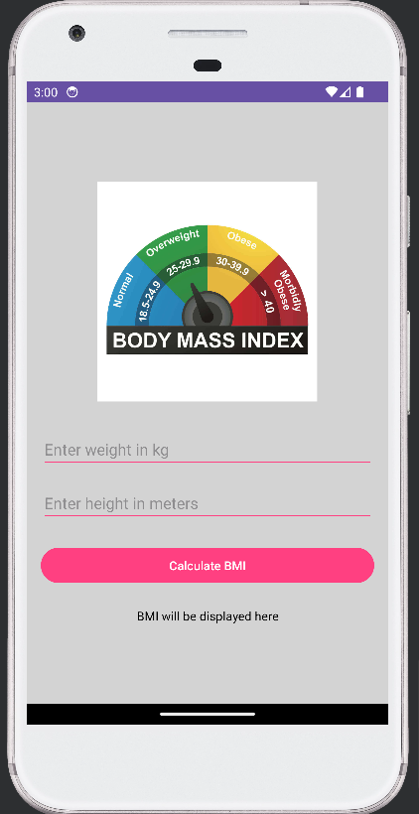

***Fig: First look***

**CHAPTER 3**

**ARCHITECTURE**

Implement the MVC design pattern to separate concerns and enhance maintainability.

* **Model-View-Controller (MVC) Design:**

Adopt a modular MVC design, separating the user interface (View) from the logic (Controller) and data (Model).

* **Activity and Fragment Design:**

Use separate activities or fragments for distinct app functionalities, such as input, calculation, and result display.

* **Input Validation:**

Implement robust input validation mechanisms to handle invalid user inputs and provide appropriate error messages.

* **BMI Calculation Logic:**

Develop clear and efficient algorithms for BMI calculation, taking into account weight and height inputs.

* **Localization:**

Plan for potential internationalization and localization to support multiple languages and regional preferences.

**CHAPTER 4**

**IMPLEMENTATION**

**Taking input of values:**

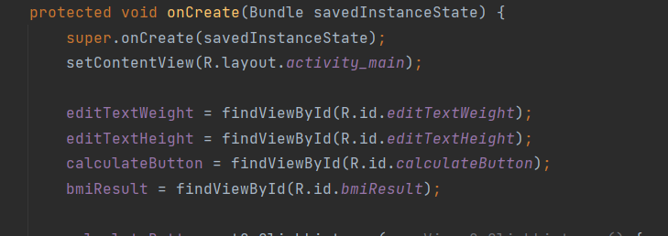

**Displaying health status:**

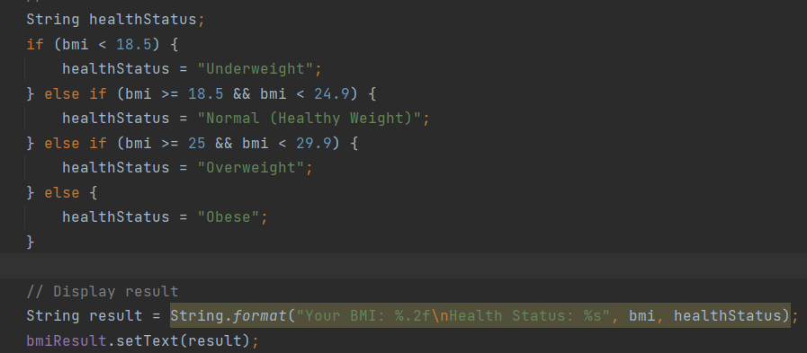

**Calculating BMI:**

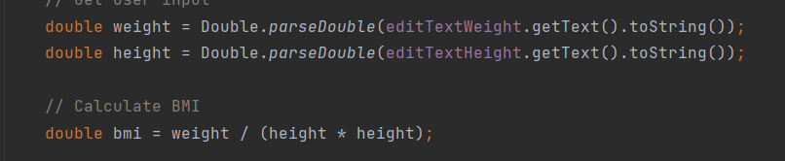

**CHAPTER 5**

**RESULTS**

On entering the weight and height values in the application we will be able to see the BMI index of our input values. Our app will also give a message of how our health is i.e; healthy, normal or obese

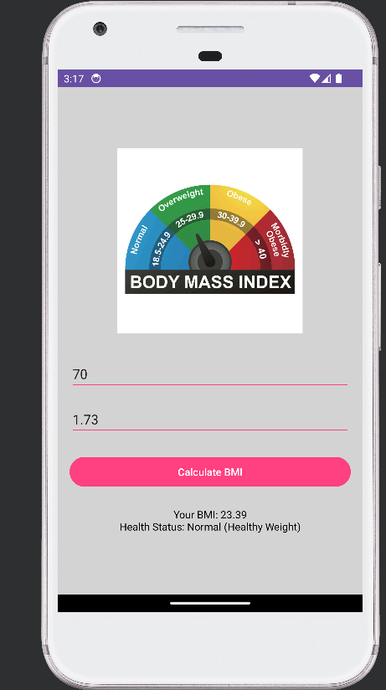 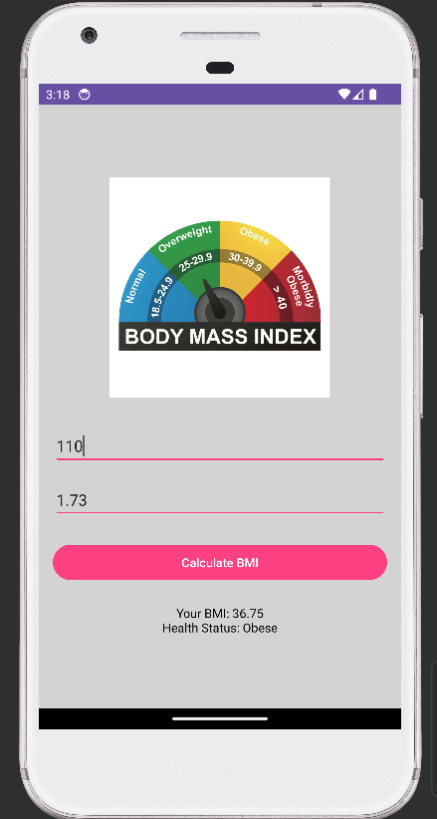

Above are the images for different output’s where in the first case the person is healthy and another case the person is obese.